20160324
# After I turned on all snmp alerts on all serves, I start receiving a lot of messages from one of servers.

# As I have understood, It’s mean, that some device is in usb port at front panel of server. And this device consume some current.
# This is unsecure.

--------------------------------------------------------------------------------
SeqNumber = 1481240
Message ID = USR0175
Category = Audit
AgentID = iDRAC
Severity = Warning
Timestamp = 2016-03-24 10:56:24
Message = The Front Panel USB Port Over Current is detected for the attached device on Disk.USBFront.1.
Message Arg 1 = 1
--------------------------------------------------------------------------------

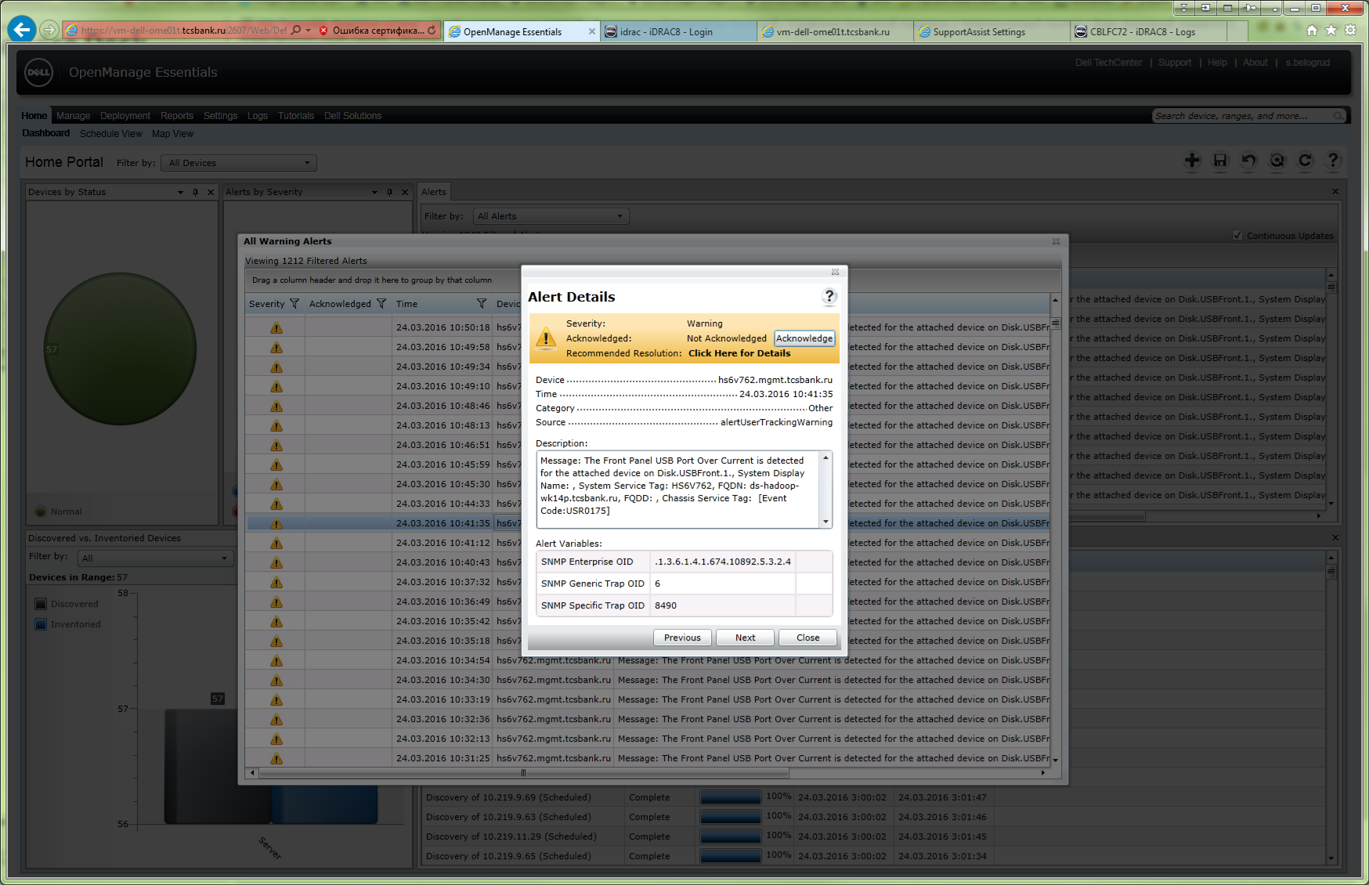

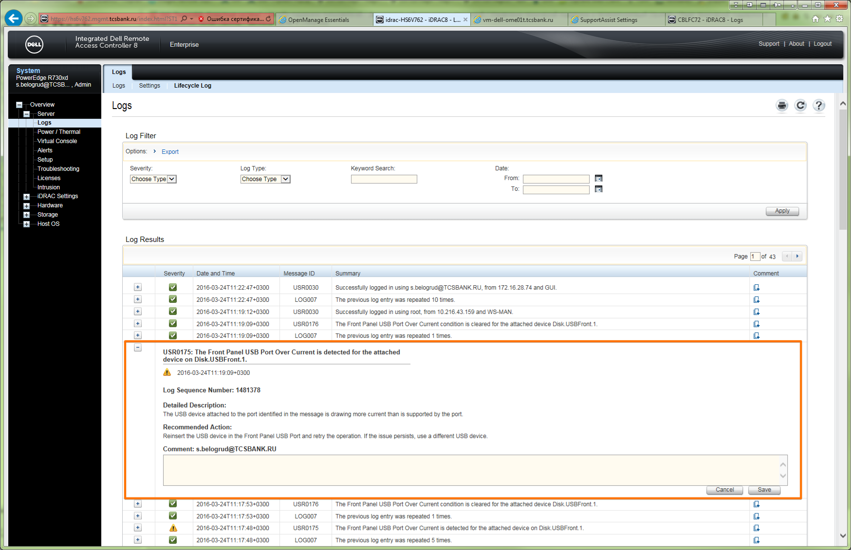

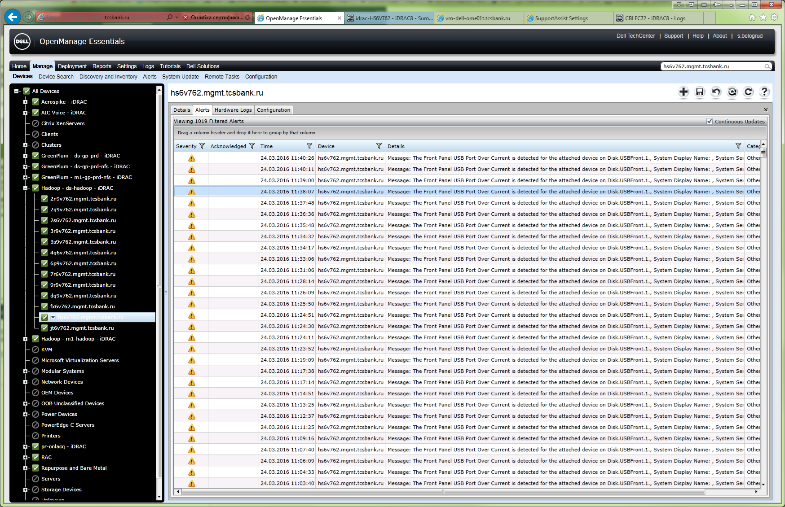

# I turned off this message sending.
# This record helps me to find what check-box in iDRAC I should use to turn off sending these messages.
# I thought follow way: this is “Alert”, this is “UserTracking”, and this is “Audit” category.
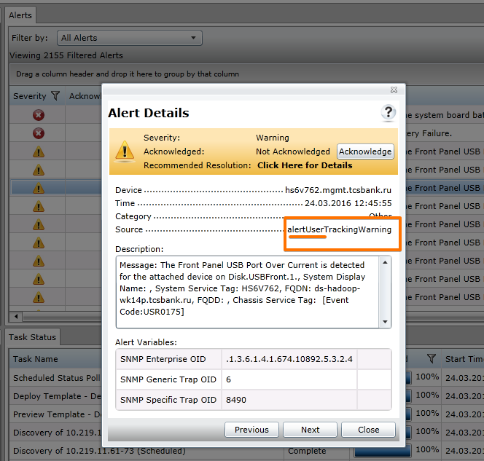

--------------------------------------------------------------------------------
SeqNumber = 1481240
Message ID = USR0175
Category = Audit
AgentID = iDRAC
Severity = Warning
Timestamp = 2016-03-24 10:56:24
Message = The Front Panel USB Port Over Current is detected for the attached device on Disk.USBFront.1.
Message Arg 1 = 1
--------------------------------------------------------------------------------

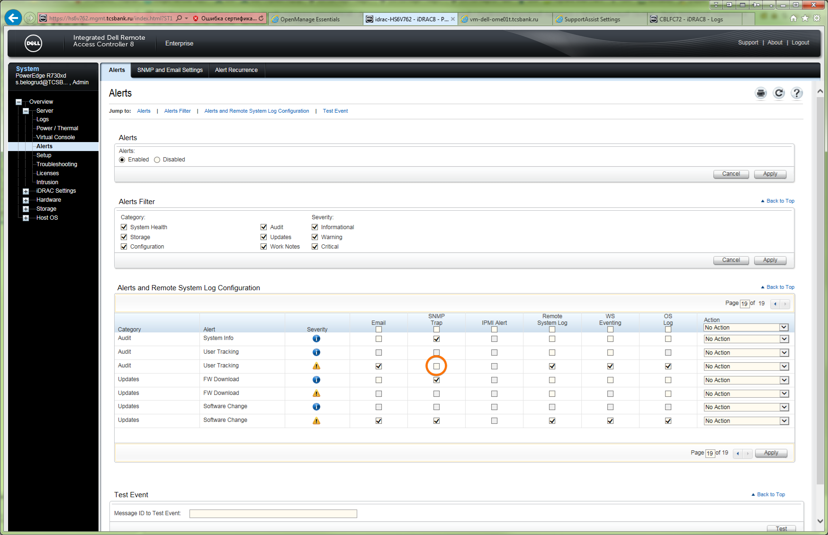

# Related messages into /var/log/messages were found and looks like below:
#
# It's was taken with vim selection
[root@ds-hadoop-wk14p ~]# cat /tmp/20160324-1154.from.messages
Mar 4 17:56:07 ds-hadoop-wk14p snmpd[3379]: [smux_parse_var] Panic: type 48
Mar 4 17:57:42 ds-hadoop-wk14p dsm_ism_srvmgrd: 4893 ISM0007 [iSM@674.10892.2 EventID="8194" EventCategory="Audit" EventSeverity="warn" IsPastEvent="false" language="en-US"] The iDRAC Service Module communication with iDRAC has ended.
Mar 4 17:58:05 ds-hadoop-wk14p kernel: usb 1-1.6: USB disconnect, device number 3
Mar 4 17:58:05 ds-hadoop-wk14p kernel: usb 1-1.6.3: USB disconnect, device number 4
Mar 4 17:58:05 ds-hadoop-wk14p kernel: cdc_ether 1-1.6.3:1.0: idrac: unregister 'cdc_ether' usb-0000:00:1a.0-1.6.3, CDC Ethernet Device
Mar 4 17:58:06 ds-hadoop-wk14p ntpd[3403]: Deleting interface #8 idrac, fe80::46a8:42ff:fe35:f50f#123, interface stats: received=0, sent=0, dropped=0, active_time=10352164 secs
Mar 4 17:58:06 ds-hadoop-wk14p ntpd[3403]: Deleting interface #7 idrac, 169.254.0.2#123, interface stats: received=0, sent=0, dropped=0, active_time=10352164 secs
Mar 4 17:58:06 ds-hadoop-wk14p ntpd[3403]: peers refreshed
Mar 4 17:58:29 ds-hadoop-wk14p kernel: usb 1-1.6: new high speed USB device number 7 using ehci_hcd
Mar 4 17:58:29 ds-hadoop-wk14p kernel: usb 1-1.6: New USB device found, idVendor=413c, idProduct=a001
Mar 4 17:58:29 ds-hadoop-wk14p kernel: usb 1-1.6: New USB device strings: Mfr=1, Product=2, SerialNumber=3
Mar 4 17:58:29 ds-hadoop-wk14p kernel: usb 1-1.6: Product: Gadget USB HUB
Mar 4 17:58:29 ds-hadoop-wk14p kernel: usb 1-1.6: Manufacturer: no manufacturer
Mar 4 17:58:29 ds-hadoop-wk14p kernel: usb 1-1.6: SerialNumber: 0123456789
Mar 4 17:58:29 ds-hadoop-wk14p kernel: usb 1-1.6: configuration #1 chosen from 1 choice
Mar 4 17:58:29 ds-hadoop-wk14p kernel: hub 1-1.6:1.0: USB hub found
Mar 4 17:58:29 ds-hadoop-wk14p kernel: hub 1-1.6:1.0: 6 ports detected
Mar 4 17:58:59 ds-hadoop-wk14p kernel: usb 1-1.6.1: new high speed USB device number 8 using ehci_hcd
Mar 4 17:58:59 ds-hadoop-wk14p kernel: usb 1-1.6.1: New USB device found, idVendor=0624, idProduct=0249
Mar 4 17:58:59 ds-hadoop-wk14p kernel: usb 1-1.6.1: New USB device strings: Mfr=4, Product=5, SerialNumber=6
Mar 4 17:58:59 ds-hadoop-wk14p kernel: usb 1-1.6.1: Product: Keyboard/Mouse Function
Mar 4 17:58:59 ds-hadoop-wk14p kernel: usb 1-1.6.1: Manufacturer: Avocent
Mar 4 17:58:59 ds-hadoop-wk14p kernel: usb 1-1.6.1: SerialNumber: 20121018
Mar 4 17:58:59 ds-hadoop-wk14p kernel: usb 1-1.6.1: configuration #1 chosen from 1 choice
Mar 4 17:58:59 ds-hadoop-wk14p kernel: input: Avocent Keyboard/Mouse Function as /devices/pci0000:00/0000:00:1a.0/usb1/1-1/1-1.6/1-1.6.1/1-1.6.1:1.0/input/input2
Mar 4 17:58:59 ds-hadoop-wk14p kernel: generic-usb 0003:0624:0249.0001: input,hidraw0: USB HID v1.00 Keyboard [Avocent Keyboard/Mouse Function] on usb-0000:00:1a.0-1.6.1/input0
Mar 4 17:58:59 ds-hadoop-wk14p kernel: input: Avocent Keyboard/Mouse Function as /devices/pci0000:00/0000:00:1a.0/usb1/1-1/1-1.6/1-1.6.1/1-1.6.1:1.1/input/input3
Mar 4 17:58:59 ds-hadoop-wk14p kernel: generic-usb 0003:0624:0249.0002: input,hidraw1: USB HID v1.00 Mouse [Avocent Keyboard/Mouse Function] on usb-0000:00:1a.0-1.6.1/input1
Mar 4 17:58:59 ds-hadoop-wk14p kernel: input: Avocent Keyboard/Mouse Function as /devices/pci0000:00/0000:00:1a.0/usb1/1-1/1-1.6/1-1.6.1/1-1.6.1:1.2/input/input4
Mar 4 17:58:59 ds-hadoop-wk14p kernel: generic-usb 0003:0624:0249.0003: input,hidraw2: USB HID v1.00 Mouse [Avocent Keyboard/Mouse Function] on usb-0000:00:1a.0-1.6.1/input2
Mar 4 17:59:00 ds-hadoop-wk14p kernel: usb 1-1.6.3: new high speed USB device number 9 using ehci_hcd
Mar 4 17:59:00 ds-hadoop-wk14p kernel: usb 1-1.6.3: New USB device found, idVendor=413c, idProduct=a102
Mar 4 17:59:00 ds-hadoop-wk14p kernel: usb 1-1.6.3: New USB device strings: Mfr=1, Product=2, SerialNumber=0
Mar 4 17:59:00 ds-hadoop-wk14p kernel: usb 1-1.6.3: Product: iDRAC Virtual NIC USB Device
Mar 4 17:59:00 ds-hadoop-wk14p kernel: usb 1-1.6.3: Manufacturer: Dell(TM)
Mar 4 17:59:00 ds-hadoop-wk14p kernel: usb 1-1.6.3: configuration #1 chosen from 2 choices
Mar 4 17:59:00 ds-hadoop-wk14p kernel: cdc_ether 1-1.6.3:1.0: usb0: register 'cdc_ether' at usb-0000:00:1a.0-1.6.3, CDC Ethernet Device, ae:4a:6b:19:d7:39
Mar 4 17:59:01 ds-hadoop-wk14p kernel: udev: renamed network interface usb0 to idrac
Mar 4 17:59:02 ds-hadoop-wk14p snmpd[3379]: IfIndex of an interface changed. Such interfaces will appear multiple times in IF-MIB.
Mar 4 17:59:06 ds-hadoop-wk14p kernel: usb 1-1.6.3: USB disconnect, device number 9
Mar 4 17:59:06 ds-hadoop-wk14p kernel: cdc_ether 1-1.6.3:1.0: idrac: unregister 'cdc_ether' usb-0000:00:1a.0-1.6.3, CDC Ethernet Device
Mar 4 17:59:18 ds-hadoop-wk14p kernel: usb 1-1.6.3: new high speed USB device number 10 using ehci_hcd
Mar 4 17:59:18 ds-hadoop-wk14p kernel: usb 1-1.6.3: New USB device found, idVendor=413c, idProduct=a102
Mar 4 17:59:18 ds-hadoop-wk14p kernel: usb 1-1.6.3: New USB device strings: Mfr=1, Product=2, SerialNumber=0
Mar 4 17:59:18 ds-hadoop-wk14p kernel: usb 1-1.6.3: Product: iDRAC Virtual NIC USB Device
Mar 4 17:59:18 ds-hadoop-wk14p kernel: usb 1-1.6.3: Manufacturer: Dell(TM)
Mar 4 17:59:18 ds-hadoop-wk14p kernel: usb 1-1.6.3: configuration #1 chosen from 2 choices
Mar 4 17:59:18 ds-hadoop-wk14p kernel: cdc_ether 1-1.6.3:1.0: eth0: register 'cdc_ether' at usb-0000:00:1a.0-1.6.3, CDC Ethernet Device, 44:a8:42:35:f5:0f
Mar 4 17:59:18 ds-hadoop-wk14p kernel: udev: renamed network interface eth0 to idrac
Mar 4 17:59:21 ds-hadoop-wk14p kernel: usb 1-1.6.1: USB disconnect, device number 8
Mar 4 18:00:34 ds-hadoop-wk14p ntpd[3403]: Listen normally on 9 idrac 169.254.0.2 UDP 123
Mar 4 18:00:34 ds-hadoop-wk14p ntpd[3403]: Listen normally on 10 idrac fe80::46a8:42ff:fe35:f50f UDP 123
Mar 4 18:00:34 ds-hadoop-wk14p ntpd[3403]: peers refreshed
Mar 4 18:00:36 ds-hadoop-wk14p dsm_ism_srvmgrd: 4893 ISM0005 [iSM@674.10892.2 EventID="8196" EventCategory="Audit" EventSeverity="info" IsPastEvent="false" language="en-US"] The iDRAC Service Module has successfully restarted communication with iDRAC.
Mar 4 18:02:35 ds-hadoop-wk14p snmpd[3379]: [smux_parse_var] Panic: type 48

[root@ds-hadoop-wk14p ~]#

# Appropriate dmesg log:
[root@ds-hadoop-wk14p ~]# dmesg
...
audit: audit_backlog=321 > audit_backlog_limit=320
audit: audit_lost=2836 audit_rate_limit=0 audit_backlog_limit=320
audit: backlog limit exceeded
NOHZ: local_softirq_pending 100
usb 1-1.6: USB disconnect, device number 3
usb 1-1.6.3: USB disconnect, device number 4
cdc_ether 1-1.6.3:1.0: idrac: unregister 'cdc_ether' usb-0000:00:1a.0-1.6.3, CDC Ethernet Device
usb 1-1.6: new high speed USB device number 7 using ehci_hcd
usb 1-1.6: New USB device found, idVendor=413c, idProduct=a001
usb 1-1.6: New USB device strings: Mfr=1, Product=2, SerialNumber=3
usb 1-1.6: Product: Gadget USB HUB
usb 1-1.6: Manufacturer: no manufacturer
usb 1-1.6: SerialNumber: 0123456789
usb 1-1.6: configuration #1 chosen from 1 choice
hub 1-1.6:1.0: USB hub found
hub 1-1.6:1.0: 6 ports detected
usb 1-1.6.1: new high speed USB device number 8 using ehci_hcd
usb 1-1.6.1: New USB device found, idVendor=0624, idProduct=0249
usb 1-1.6.1: New USB device strings: Mfr=4, Product=5, SerialNumber=6
usb 1-1.6.1: Product: Keyboard/Mouse Function
usb 1-1.6.1: Manufacturer: Avocent
usb 1-1.6.1: SerialNumber: 20121018
usb 1-1.6.1: configuration #1 chosen from 1 choice
input: Avocent Keyboard/Mouse Function as /devices/pci0000:00/0000:00:1a.0/usb1/1-1/1-1.6/1-1.6.1/1-1.6.1:1.0/input/input2
generic-usb 0003:0624:0249.0001: input,hidraw0: USB HID v1.00 Keyboard [Avocent Keyboard/Mouse Function] on usb-0000:00:1a.0-1.6.1/input0
input: Avocent Keyboard/Mouse Function as /devices/pci0000:00/0000:00:1a.0/usb1/1-1/1-1.6/1-1.6.1/1-1.6.1:1.1/input/input3
generic-usb 0003:0624:0249.0002: input,hidraw1: USB HID v1.00 Mouse [Avocent Keyboard/Mouse Function] on usb-0000:00:1a.0-1.6.1/input1
input: Avocent Keyboard/Mouse Function as /devices/pci0000:00/0000:00:1a.0/usb1/1-1/1-1.6/1-1.6.1/1-1.6.1:1.2/input/input4
generic-usb 0003:0624:0249.0003: input,hidraw2: USB HID v1.00 Mouse [Avocent Keyboard/Mouse Function] on usb-0000:00:1a.0-1.6.1/input2
usb 1-1.6.3: new high speed USB device number 9 using ehci_hcd
usb 1-1.6.3: New USB device found, idVendor=413c, idProduct=a102
usb 1-1.6.3: New USB device strings: Mfr=1, Product=2, SerialNumber=0
usb 1-1.6.3: Product: iDRAC Virtual NIC USB Device
usb 1-1.6.3: Manufacturer: Dell(TM)
usb 1-1.6.3: configuration #1 chosen from 2 choices
cdc_ether 1-1.6.3:1.0: usb0: register 'cdc_ether' at usb-0000:00:1a.0-1.6.3, CDC Ethernet Device, ae:4a:6b:19:d7:39
udev: renamed network interface usb0 to idrac
usb 1-1.6.3: USB disconnect, device number 9
cdc_ether 1-1.6.3:1.0: idrac: unregister 'cdc_ether' usb-0000:00:1a.0-1.6.3, CDC Ethernet Device
usb 1-1.6.3: new high speed USB device number 10 using ehci_hcd
usb 1-1.6.3: New USB device found, idVendor=413c, idProduct=a102
usb 1-1.6.3: New USB device strings: Mfr=1, Product=2, SerialNumber=0
usb 1-1.6.3: Product: iDRAC Virtual NIC USB Device
usb 1-1.6.3: Manufacturer: Dell(TM)
usb 1-1.6.3: configuration #1 chosen from 2 choices
cdc_ether 1-1.6.3:1.0: eth0: register 'cdc_ether' at usb-0000:00:1a.0-1.6.3, CDC Ethernet Device, 44:a8:42:35:f5:0f
udev: renamed network interface eth0 to idrac
usb 1-1.6.1: USB disconnect, device number 8
idrac: no IPv6 routers present
[root@ds-hadoop-wk14p ~]#

# In hardware log was not found some interesting.
#
[support@centos00 ~]$ ssh tcsbank.ru\\s.belogrud@HS6V762.mgmt.tcsbank.ru racadm getsel
The authenticity of host 'hs6v762.mgmt.tcsbank.ru (10.219.11.66)' can't be established.
RSA key fingerprint is 69:65:33:50:73:6f:2f:da:30:c7:57:3c:04:b3:89:44.
Are you sure you want to continue connecting (yes/no)? yes
Warning: Permanently added 'hs6v762.mgmt.tcsbank.ru,10.219.11.66' (RSA) to the list of known hosts.
tcsbank.ru\s.belogrud@hs6v762.mgmt.tcsbank.ru's password:
Record: 1
Date/Time: 06/27/2015 03:47:49
Source: system
Severity: Ok
Description: Log cleared.
-------------------------------------------------------------------------------
Record: 2
Date/Time: 06/27/2015 04:02:57
Source: system
Severity: Ok
Description: C: boot completed.
-------------------------------------------------------------------------------
Record: 3
Date/Time: 06/27/2015 04:02:57
Source: system
Severity: Ok
Description: OEM software event.
-------------------------------------------------------------------------------
Record: 4
Date/Time: 08/06/2015 11:41:33
Source: system
Severity: Critical
Description: The chassis is open while the power is off.
-------------------------------------------------------------------------------
Record: 5
Date/Time: 08/06/2015 11:41:38
Source: system
Severity: Ok
Description: The chassis is closed while the power is off.
-------------------------------------------------------------------------------
Record: 6
Date/Time: 08/11/2015 12:31:45
Source: system
Severity: Critical
Description: Power supply redundancy is lost.
-------------------------------------------------------------------------------
Record: 7
Date/Time: 08/11/2015 12:31:45
Source: system
Severity: Critical
Description: The power input for power supply 2 is lost.
-------------------------------------------------------------------------------
Record: 8
Date/Time: 08/11/2015 12:34:34
Source: system
Severity: Ok
Description: The input power for power supply 2 has been restored.
-------------------------------------------------------------------------------
Record: 9
Date/Time: 08/11/2015 12:34:39
Source: system
Severity: Ok
Description: The power supplies are redundant.
-------------------------------------------------------------------------------
Record: 10
Date/Time: 08/11/2015 12:35:20
Source: system
Severity: Critical
Description: Power supply redundancy is lost.
-------------------------------------------------------------------------------
Record: 11
Date/Time: 08/11/2015 12:35:25
Source: system
Severity: Critical
Description: The power input for power supply 1 is lost.
-------------------------------------------------------------------------------
Record: 12
Date/Time: 08/11/2015 12:41:35
Source: system
Severity: Ok
Description: The input power for power supply 1 has been restored.
-------------------------------------------------------------------------------
Record: 13
Date/Time: 08/11/2015 12:41:41
Source: system
Severity: Ok
Description: The power supplies are redundant.
-------------------------------------------------------------------------------
[support@centos00 ~]$

[support@centos00 ~]$ ssh tcsbank.ru\\s.belogrud@HS6V762.mgmt.tcsbank.ru racadm getraclog | tee -a /tmp/20160324-1233.getraclog.ds-hadoop-wk14p.log
SeqNumber = 1481826
Message ID = USR0030
Category = Audit
AgentID = RACLOG
Severity = Information
Timestamp = 2016-03-24 12:34:21
Message = Successfully logged in using s.belogrud@tcsbank.ru, from 172.16.28.74 and SSH.
Message Arg 1 = s.belogrud@tcsbank.ru
Message Arg 2 = 172.16.28.74
Message Arg 3 = SSH
FQDD = iDRAC.Embedded.1
--------------------------------------------------------------------------------
SeqNumber = 1481825
Message ID = USR0176
Category = Audit
AgentID = iDRAC
Severity = Information
Timestamp = 2016-03-24 12:33:27
Message = The Front Panel USB Port Over Current condition is cleared for the attached device Disk.USBFront.1.
Message Arg 1 = 1
...
--------------------------------------------------------------------------------
SeqNumber = 1481246
Message ID = USR0175
Category = Audit
AgentID = iDRAC
Severity = Warning
Timestamp = 2016-03-24 10:56:38
Message = The Front Panel USB Port Over Current is detected for the attached device on Disk.USBFront.1.
Message Arg 1 = 1
--------------------------------------------------------------------------------
SeqNumber = 1481245
Message ID = LOG007
Category = Audit
AgentID = DE
Severity = Information
Timestamp = 2016-03-24 10:56:38
Message = The previous log entry was repeated 4 times.
Message Arg 1 = 4
--------------------------------------------------------------------------------
SeqNumber = 1481244
Message ID = USR0030
Category = Audit
AgentID = RACLOG
Severity = Information
Timestamp = 2016-03-24 10:56:33
Message = Successfully logged in using root, from 10.216.43.159 and WS-MAN.
Message Arg 1 = root
Message Arg 2 = 10.216.43.159
Message Arg 3 = WS-MAN
FQDD = iDRAC.Embedded.1
--------------------------------------------------------------------------------
SeqNumber = 1481243
Message ID = USR0176
Category = Audit
AgentID = iDRAC
Severity = Information
Timestamp = 2016-03-24 10:56:28
Message = The Front Panel USB Port Over Current condition is cleared for the attached device Disk.USBFront.1.
Message Arg 1 = 1
--------------------------------------------------------------------------------
SeqNumber = 1481242
Message ID = USR0175
Category = Audit
AgentID = iDRAC
Severity = Warning
Timestamp = 2016-03-24 10:56:24
Message = The Front Panel USB Port Over Current is detected for the attached device on Disk.USBFront.1.
Message Arg 1 = 1
--------------------------------------------------------------------------------
SeqNumber = 1481241
Message ID = USR0030
Category = Audit
AgentID = RACLOG
Severity = Information
Timestamp = 2016-03-24 10:56:24
Message = Successfully logged in using root, from 10.216.43.159 and WS-MAN.
Message Arg 1 = root
Message Arg 2 = 10.216.43.159
Message Arg 3 = WS-MAN
FQDD = iDRAC.Embedded.1
--------------------------------------------------------------------------------
SeqNumber = 1481240
Message ID = USR0175
Category = Audit
AgentID = iDRAC
Severity = Warning
Timestamp = 2016-03-24 10:56:24
Message = The Front Panel USB Port Over Current is detected for the attached device on Disk.USBFront.1.
Message Arg 1 = 1
--------------------------------------------------------------------------------
SeqNumber = 1481239
Message ID = LOG007
Category = Audit
AgentID = DE
Severity = Information
Timestamp = 2016-03-24 10:56:24
Message = The previous log entry was repeated 9 times.
Message Arg 1 = 9
--------------------------------------------------------------------------------
SeqNumber = 1481238
Message ID = USR0030
Category = Audit
AgentID = RACLOG
Severity = Information
Timestamp = 2016-03-24 10:56:16
Message = Successfully logged in using root, from 10.216.43.159 and WS-MAN.
Message Arg 1 = root
Message Arg 2 = 10.216.43.159
Message Arg 3 = WS-MAN
FQDD = iDRAC.Embedded.1
--------------------------------------------------------------------------------
SeqNumber = 1481237
Message ID = USR0176
Category = Audit
AgentID = iDRAC
Severity = Information
Timestamp = 2016-03-24 10:56:15
Message = The Front Panel USB Port Over Current condition is cleared for the attached device Disk.USBFront.1.
Message Arg 1 = 1
--------------------------------------------------------------------------------
Timeout, server not responding.
[support@centos00 ~]$

